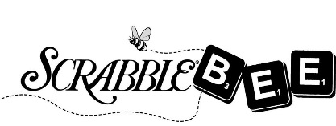

*Each player will complete their own Pledge Form. Please ask your friends, family, neighbors & co-workers to pledge a donation toward the 2020 Scrabble Bee event. Top fund-raisers win prizes! Pledge online by going to* [*http://www.literacycv.org*](http://www.literacycv.org) *and click on the ScrabbleBee banner.*

Pledge Form

**Your Name**: _____________________________________________

**Team Name**: ____________________________________________

**Company/Organization**: ___________________________________

**Bring this pledge form and your pledge money to the Scrabble Bee event Thursday, April 16th.**

**Questions? Call 715-834-0222**

|  |  |  |  |  |  |
| --- | --- | --- | --- | --- | --- |
| **Name** | **Address** | **Phone** | **E-mail Address** | **Pledge Amount** | **Cash / Check / On-line** |
|  |  |  |  |  |  |
|  |  |  |  |  |  |
|  |  |  |  |  |  |
|  |  |  |  |  |  |
|  |  |  |  |  |  |
|  |  |  |  |  |  |
|  |  |  |  |  |  |
|  |  |  |  |  |  |
|  |  |  |  |  |  |
|  |  |  |  |  |  |
|  |  |  |  |  |  |
|  |  |  |  |  |  |
|  |  |  |  |  |  |
|  |  |  |  |  |  |