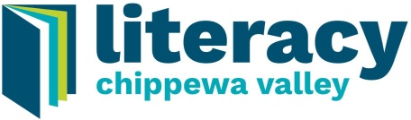
19th Annual
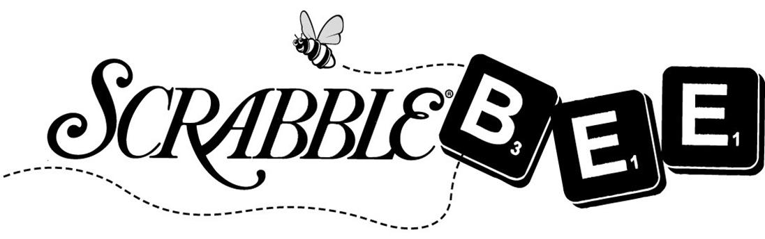

April 16, 2020

Basket/Item Donation Form
(Literacy Chippewa Valley is a 501(c)(3) nonprofit organization making donations tax deductible)

First Name: |  |  |  |  |  |  |  |  | Last Name:
Business/Organization Name (If Applicable):
Address: |  |  |  |  |  |  |  | City: |  |  |  |  | Zip:
Email Address: |  |  |  |  |  |  |  |  |  | Phone #:
Basket/Item Title:
Basket/Item Theme:
Basket/Item Contents:
Basket/Item Value:

We are hoping for baskets to be donated at a value of approximately $125, or can be combined with other items to total $125.

Basket Delivery
__ I would like someone to pick up my basket/item.
__ I will drop off my basket/item.

Baskets should be in our office no later than Friday, April 10, 2019. Please contact us at 715.834.0222 with any questions. We appreciate your generosity!

Our office is located at:
An Excerpt from “Will You Forgive Me?” by Tony Ross (Celebrate Writing 2019)

We all have a story, one that shaped us, molded us into who we are. My story has had a lot of negative, some positive. But at 50 years old, I have finally realized my story doesn’t have to end with addiction, that I am in control of the ending and I can write the final chapters, ones that include sobriety, education, family, and happiness.

We don’t have to let our past determine our future. Take control and start writing your own story, the story you want your life to be. Please, before you end up in jail, just know that you have opportunities through programs and determination, you are in control.

Write your own ending!

Literacy Chippewa Valley
Wilson Building
510 S. Farwell Street
Eau Claire, WI 54701

Office Hours:
Monday 8:00 a.m. to 1:00 p.m.
Tuesday 8:00 a.m. to 1:00 p.m.
Wednesday 8:00 a.m. to 1:00 p.m.
Thursday 8:00 a.m. to 1:00 p.m.
Friday By Appointment
Literacy changes everything.

