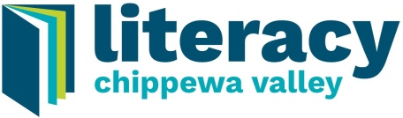
20th Annual
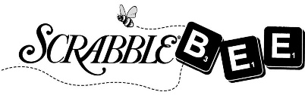

April 30, 2021

Basket/Item Donation Form
(Literacy Chippewa Valley is a 501(c)(3) nonprofit organization making donations tax deductible)

First Name: |  |  |  |  |  |  |  |  | Last Name:
Business/Organization Name (If Applicable):
Address: |  |  |  |  |  |  |  | City: |  |  |  |  | Zip:
Email Address: |  |  |  |  |  |  |  |  |  | Phone #:
Basket/Item Title:
Basket/Item Theme:
Basket/Item Contents:
Basket/Item Value:

We are hoping for baskets to be donated at a value of approximately $125, or can be combined with other items to total $125.

Basket Delivery
__ I would like someone to pick up my basket/item.
__ I will drop off my basket/item.

Baskets should be in our office no later than Friday, April 10, 2019. Please contact us at 715.834.0222 with any questions. We appreciate your generosity!

Our office is located at:
Literacy Chippewa Valley
Wilson Building
510 S. Farwell Street
Eau Claire, WI 54701

Office Hours:
Monday 8:00 a.m. to 12:00 p.m.
Tuesday 8:00 a.m. to 12:00 p.m.
Wednesday 8:00 a.m. to 12:00 p.m.
Thursday 8:00 a.m. to 12:00 p.m.
Friday By Appointment
Literacy changes everything.

